Images for Memes and Social Media Posts about SNAP/CalFresh:
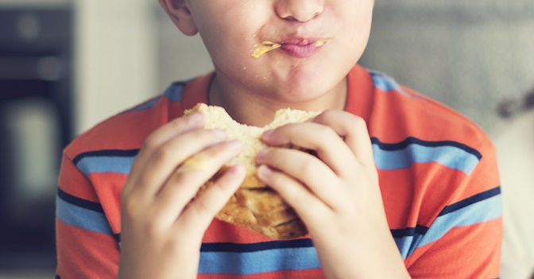  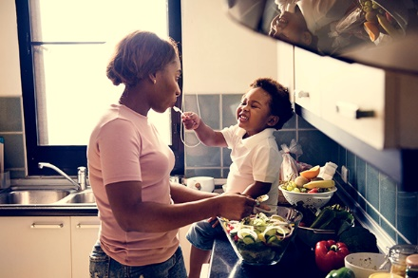  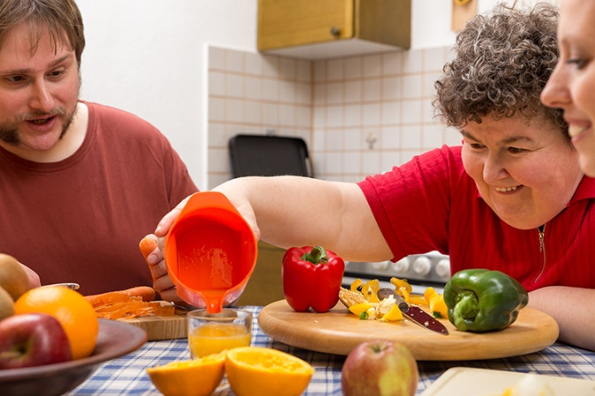 | #SNAPWorks to keep America's kids from going hungry. 44% of Supplemental Nutrition Assistance Program recipients are children. Americans deserve a strong nutritional safety net in the Farm Bill. RT if you want to #EndHunger in the #FarmBill18  #SNAPmatters to the over 11 million people with disabilities who depend on our safety net. In fact, they make up 26% of all people on the supplemental nutrition assistance program. RT if you believe that the #FarmBill2018 should take of those with disabilities. #EndHunger  #SNAPmatters for households with children, seniors, and the disabled who make up 88% of Supplemental Nutrition Assistance Program recipients. RT if you believe Americans deserve a #FarmBill18 that helps feed families.

